International Advanced course
for Mediators
2018

When? Sunday 23rd – Friday 28th September 2018

Where? Casamora Hamlet, mid-way between Florence and Arezzo in Tuscany
http://www.tuscanynowandmore.com/villas/the-hamlet-casamora/

How much? £3850.00 (VAT not applicable). £850 deposit required to reserve a place.

Who for? Experienced mediators. This course is intended to push the boundaries of both participants and faculty.

Who are the faculty? Heather Allen, Lawrence Kershen QC, David Richbell from the UK and Joanna Kalowski from Australia

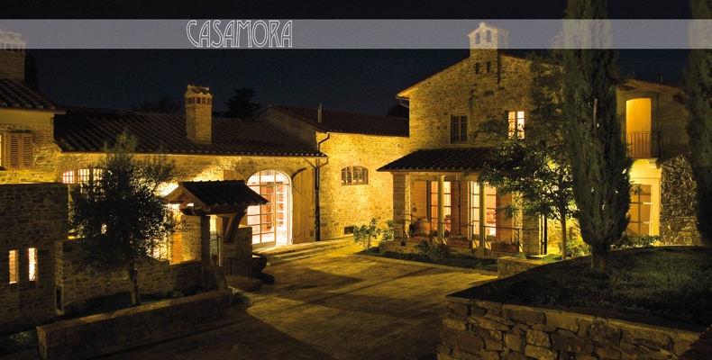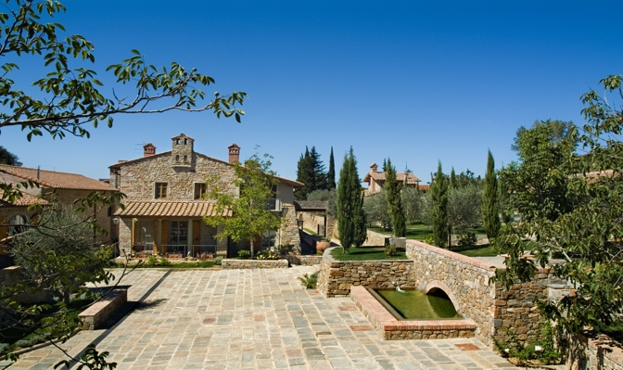

This is a development of the highly successful course run in 2016. It provides experienced mediators with the opportunity to learn, share and practise in a stunning location. We have sole use of Casamora, which has wifi and a large swimming pool. We work in the cloisters, garden, pool loggia, library and dining area and there are comfortable and informal spaces for participants to meet after dinner. Every room has en-suite facilities.
Casamora is set in a 1,000 ha estate which nestles on the sunny, western side of the Pratomagno mountain range. It has its own restaurant which uses the estate’s organic produce as well as its award-winning olive oil.
The price includes everything from collection from/delivery to Florence airport (or Figline railway station), accommodation, all meals, copy of “How to master commercial mediation” (or £50 credit if you already have a copy!), course materials and training. Wine and bar bills are excluded.

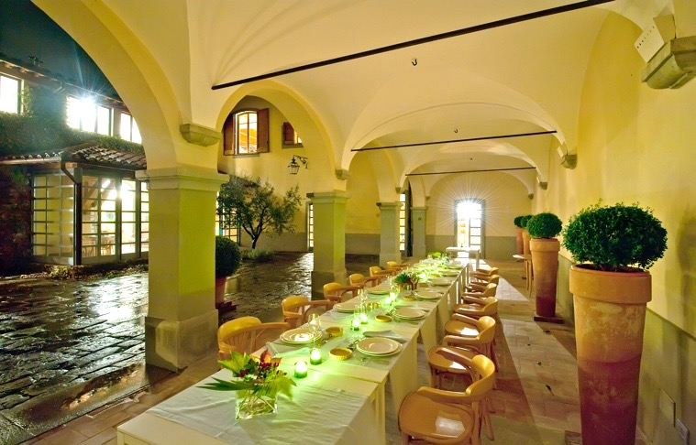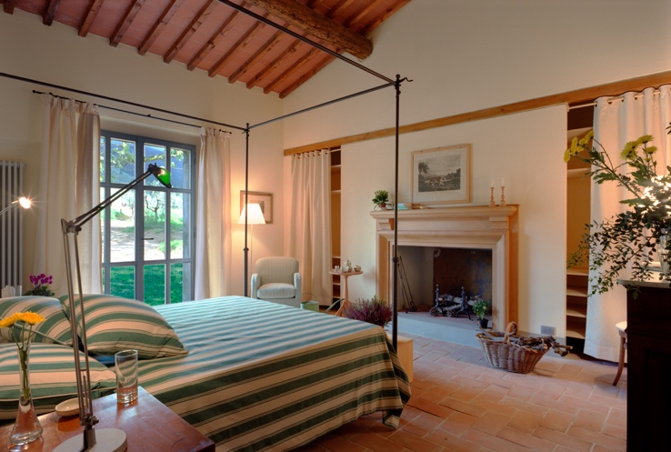

In 2016 we had six different jurisdictions represented. Here are some of the participant comments:

What to say? superb, peaceful.
I think what has struck me was the breadth of what we covered – practical skills, philosophical debate and scientific frameworks. All the stories and anecdotes ………will stay with me for a long time. I also met a great diverse interesting group of people who have done some amazing things. It was great and I couldn’t recommend it highly enough.
Thanks for an extraordinary time, and putting together such fantastic people.
Congratulations for a wonderful conference. One of the rare conferences that could not be improved upon in any way. Not much encouragement needed to draw me back again.
This is a belated and inadequate thank you for running such an interesting, challenging and enjoyable course.
Framed by an incomparable setting but made by the people
Thanks for inviting me. The time/distance/cost was worth it.
Richly fulfilling and stimulating content.
Took me to wider horizons I hadn’t expected. Flow was superb.
Ratio faculty / trainees very good. Diversity in approach and styles is a great asset.

To book
Please email David Richbell (david@richbell.org) to book a place. Reservation will be confirmed by payment of £850.00 deposit. Balance (£3000.00) is due on or before 1st July 2018.
Bank: HSBC Bank Plc, 19 Midsummer Place, Milton Keynes MK9 3GB
Sort code: 40 33 33
Account: 12514109
Name: The Dispute Resolution Partnership
BIC: HBUKGB4111L
IBAN: GB92HBUK40333312514109

